Lab 3

Q1(2pt): What’s the location of Las Cruces, NM in DMS format?

The DMS location of Las Cruces is 106°47’55.087”W, 32°4’47.74”N.

Q2 (2pt): What’s the location of Las Cruces, NM in Decimal Degrees format?

The DD location of Las Cruces is -106.941403, 32.365463.

Q3 (2pts): What’s the distance between Las Cruces and Sydney, Australia in kilometers?

The distance between Las Cruces and Sydney is 12,948.735284 Km.

Q4 (2pts): What’s the distance between Las Cruces and Sydney, Australia in miles?

The distance between Las Cruces and Sydney is 8045.95499 miles.

Q5 (4 pts): For the North Pole Azimuthal Equidistant, are the latitude and longitude lines straight lines intersecting at right angles? Are the geometric symbols still circles? How are they distorted? Is the distortion the same in all parts of the map?

The latitude and longitude lines are not intersecting at right angles, they grow as they move farther from the North Pole. The circles are also distorted horizontally smaller towards the pole and stretching out as they move away from it, with vertical length being preserved to some degree.

Q6 (4pts): Describe the transformation of the circles when you applied the each of the three projections. Are there any true circles in these projection? If so, which ones? What does the different sizes of the circles tell you about distortion?

In the Azimuthal N.P., the circles became more horizontally distorted the closer they were to the North Pole. In the Asia N. Albers the circles are also horizontally distorted however there is less than the previous and the vertical component appears more distorted especially around the south of the map. Finally, in the Miller Projection the circles near the equator are more uniform in shape while the ones near the poles are more distorted vertically, with the horizontal distance being more preserved.

Q7 (4pts): Compare the Mollweide and Robinson projections. Name your chosen projections and, in a few sentences, discuss which one distorts the most or least in terms of shape, area, and distance and which one is the most pleasing visually, in your opinion. Include Screenshots of both projections.

The Mollweide projection has the most horizontal distortion along the poles while the equator is more or less conserved as well as vertical distance. It also has a good amount of area and distortion as it preserves vertical length. Robinson Projection keeps the horizontal distance more effectively while also maintaining a steady vertical length of each circle. It distorts area and size more due to this, however it preserves the overall circle measurements more than Mollweide and is therefore the best of the two.

Mollweide:

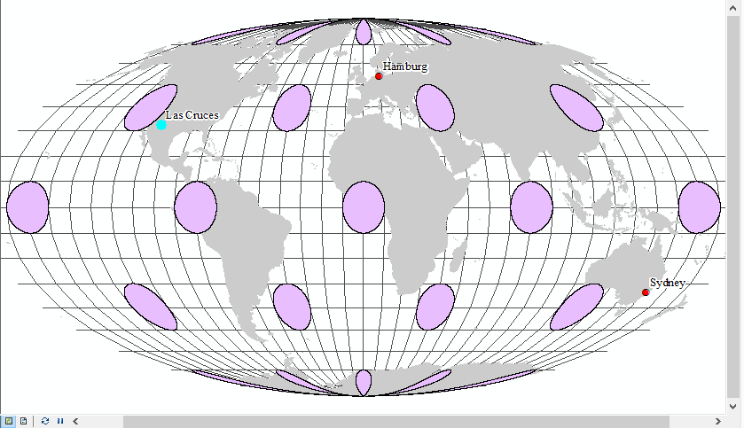

Robinson:

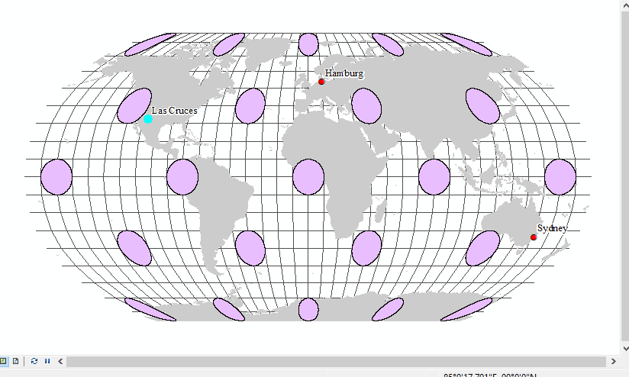

Q8 (6pts): Compare the Albers Equal Area, Lambert Conformal Conic, and Equidistant Conic projections. Name the projections and discuss which one distorts the most or least in terms of shape, area, and distance and which one is the most pleasing visually. Include screen captures of all three projections.

The albers projection seems to distort the circles vertical distance more as they travel north, whereas it maintains horizontal distance and therefore distorts area more than Lambert. The lambert and equidistant circles both have some degree of vertical distance distortion as they go north, however the lambert seems to preserve horizontal distance more effectively and therefore area as well. The equidistant has much more vertical distortion but it is more uniformly across the map, turning the circles into the ellipses we see.

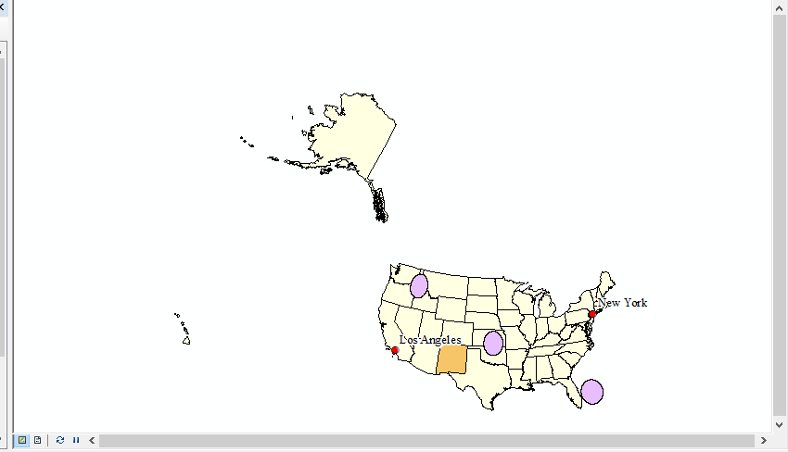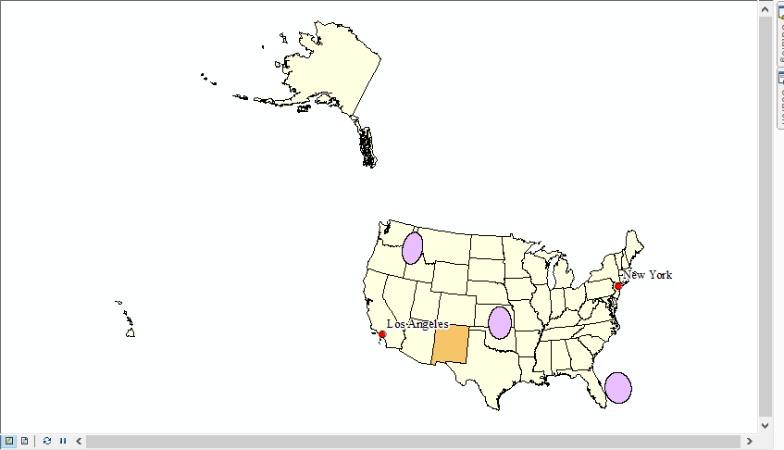Albers: Lambert:

Equidistant:

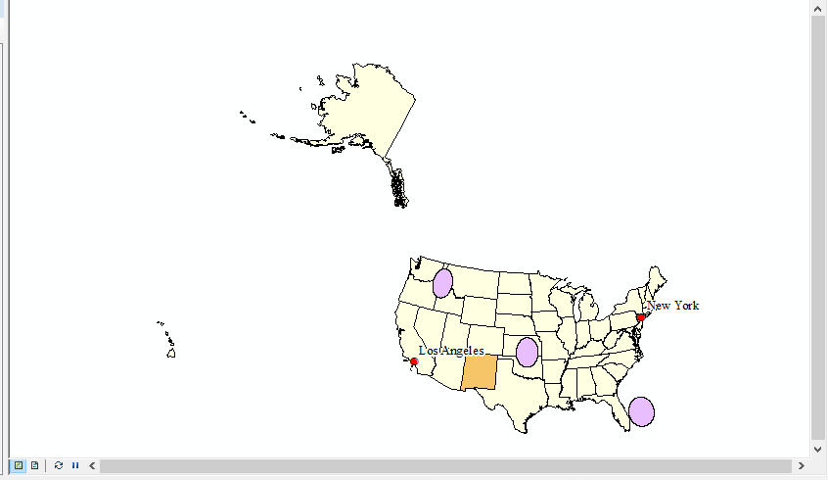

Q9 (4pts): Take a Screen Capture of your final modified projection.

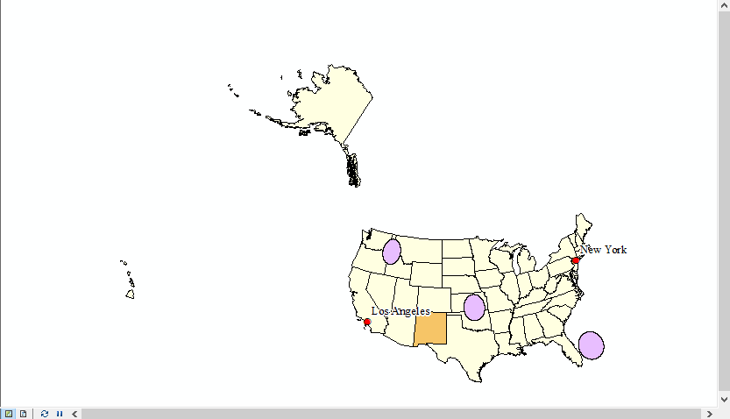

Q10 (1pts): What’s the projection used with the State Plane Coordinate System you just selected?

The projection used with the SPCS is the Transverse Mercator.

Q11 (5pts): Fill out the following information about the Coordinate System you just selected:

a. Spheroid _________________________ Clarke 1866

b. Central meridian _________________________-106.25

c. Latitude of origin_________________________31.0

d. False easting _________________________500000.0

e. False northing _________________________0.0

Q12 (4 pts): Add a screenshot of the Source tab for NM_BLM-Wilderness

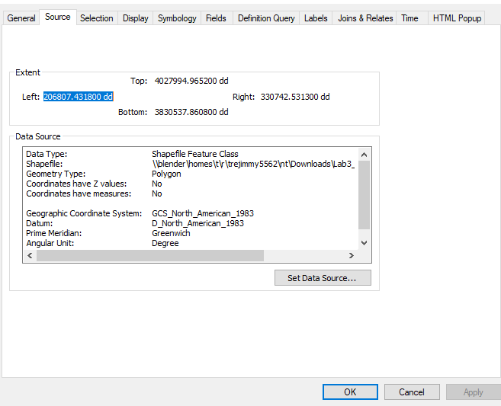

Q13 (10 pts): Consider what you have learned about projections at the world, US, and state

scales. Based on how different projections change both the level of distortion in maps as well as

their visual appeal, discuss in a paragraph (5 sentences) why projections are critical to consider

when developing maps in cartography.

Projections are critical when creating a map or cartographic representation to display. Depending on size of area being analyzed, location, and which dimensions of the map want to be accurately represented. In some cases, distances to cities are represented extremely accurately however this generally comes at the expense of area of the whole or shape. Sometimes area and shape are kept accurate by the projection however if you were to measure distances between locations, they would not be extremely accurate. These differences in representative dimensions by projections are extremely important when conveying information through your map and must be carefully considered before a choice can be made.